**Day 5 - Testing, Error Handling, and Backend Integration Refinement (Nike app)**

**Overview**

Day 5 focused on ensuring that the marketplace is ready for deployment by thoroughly testing all components and refining its backend integrations. Key activities included validation of product pages, API error handling, and responsiveness checks across mobile devices.

* **Test Cases**: A total of 7 test cases were executed, all of which passed successfully. Critical tests included the validation of product listings and details, API error handling with fallback mechanisms, and mobile responsiveness.

**Lighthouse Performance**: The app achieved excellent performance scores—94 for accessibility, 100 for SEO, and 100 for best practices. These scores indicate that the app is optimized for a wide range of users.

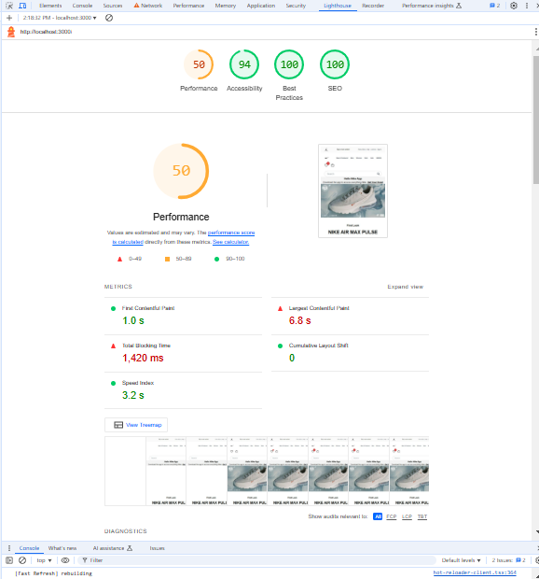

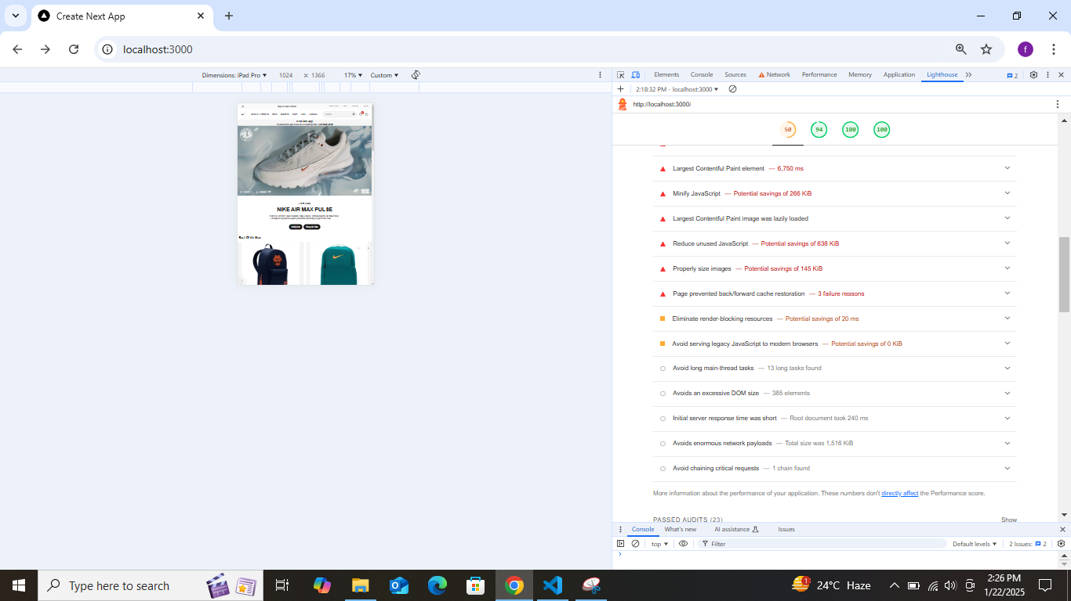

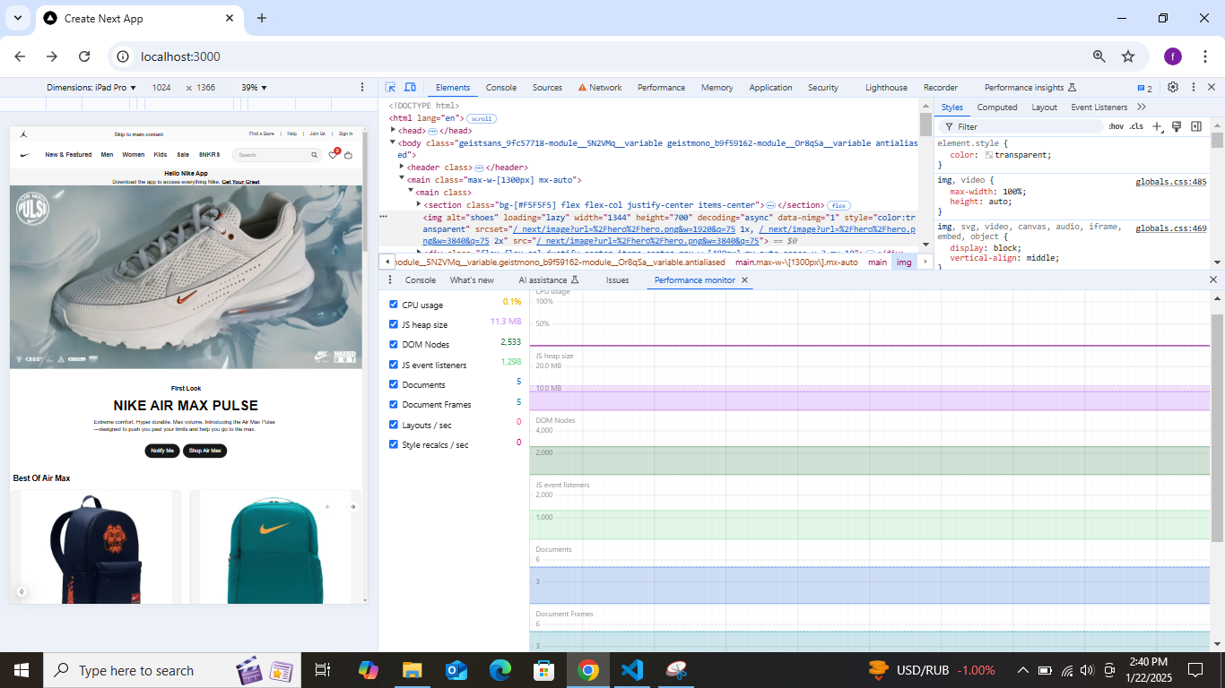

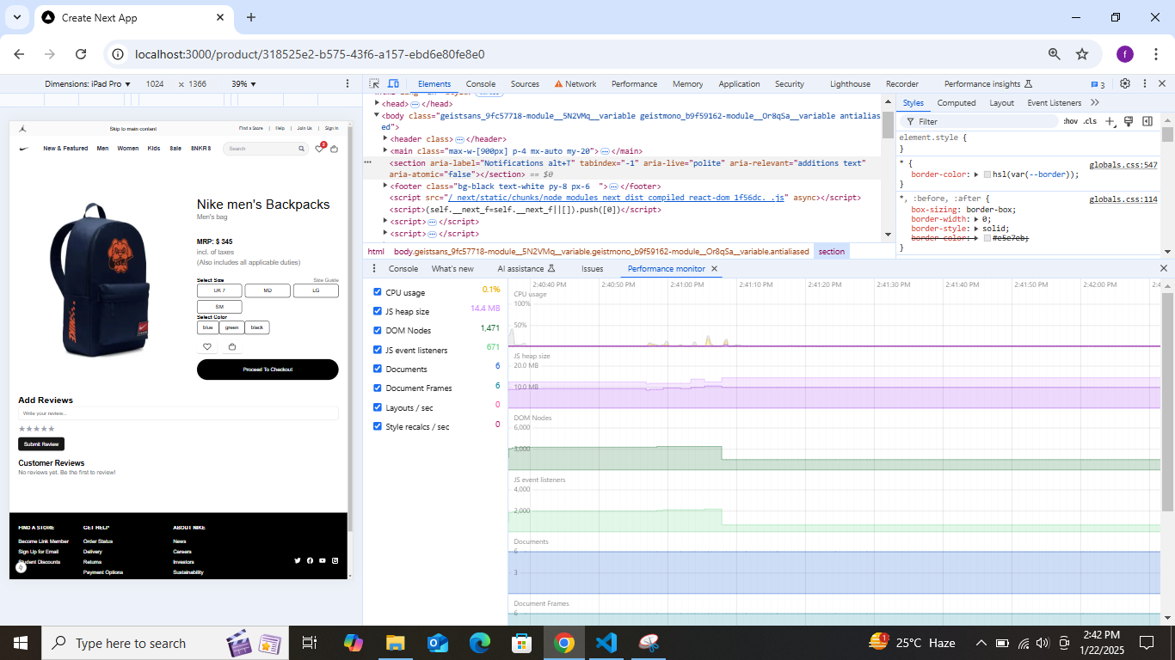

• **Debugging and Monitoring**: The network tab insights revealed no errors in resource fetching, and API requests had minimal delays with optimized payloads. The performance monitoring confirmed that the app's DOM size and event listeners were optimized for responsive behavior, and JS heap size remained stable under load.

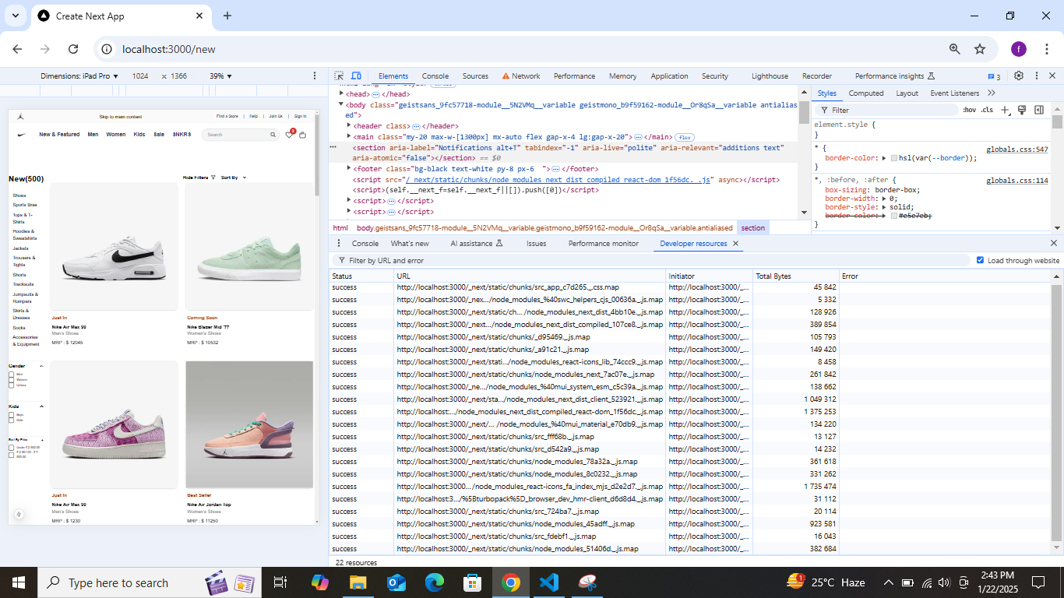

• **Responsiveness**: The app was tested to ensure it remains fully functional and visually consistent across devices.

• **Security**: A test under a non-HTTPS origin revealed the need for implementing HTTPS for better security and user trust.

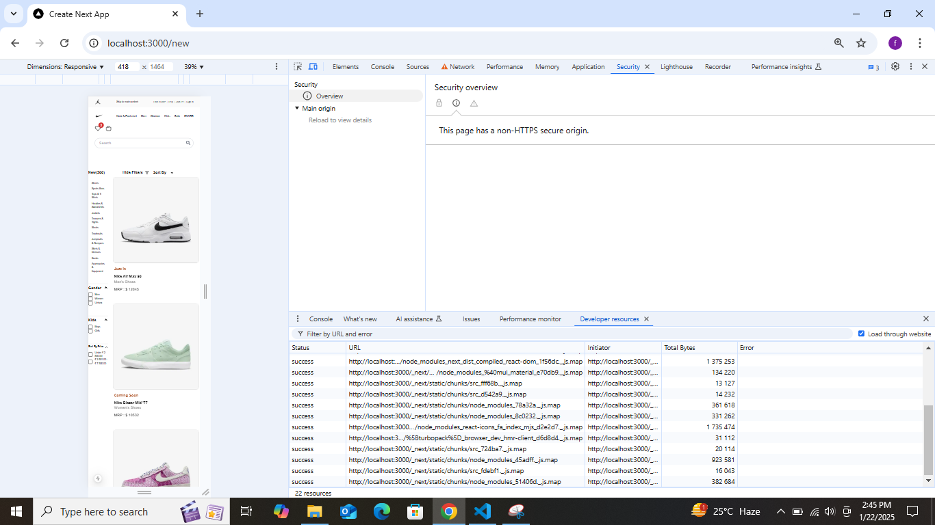

**API Response Validation**: API endpoints were tested via Postman, confirming that responses were accurate with a valid data structure and a successful 200 OK status.

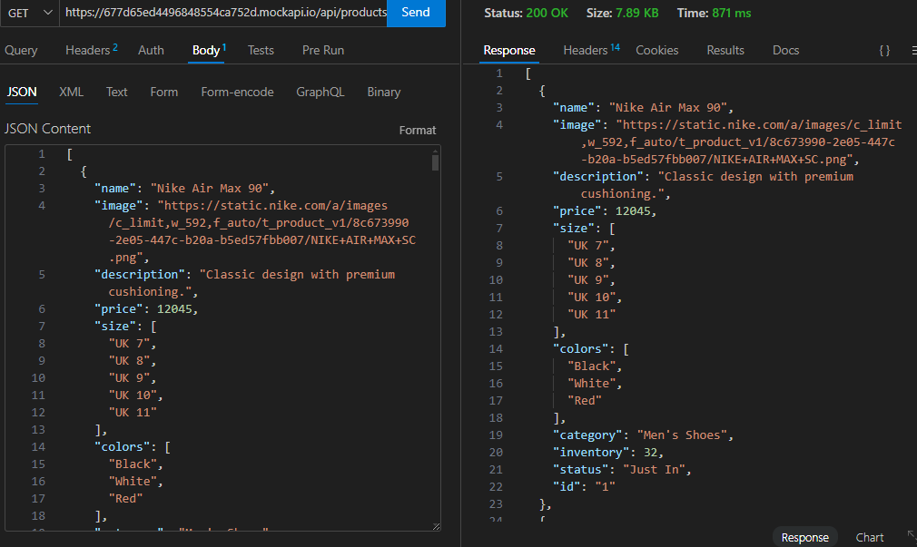

Conclusion -Day 5's focus on testing, error handling, and backend integration has successfully prepared the marketplace for real-world deployment, ensuring it is optimized for performance, responsive, and secure.